CSS and HTML – Web Fundamentals

Dining Project

Was created a folder called Project – Index, About, FAQ and Contact tambem foi criado tres pastas, um para imagen – img , style css – style e uma com documentacoes de prototipagem.

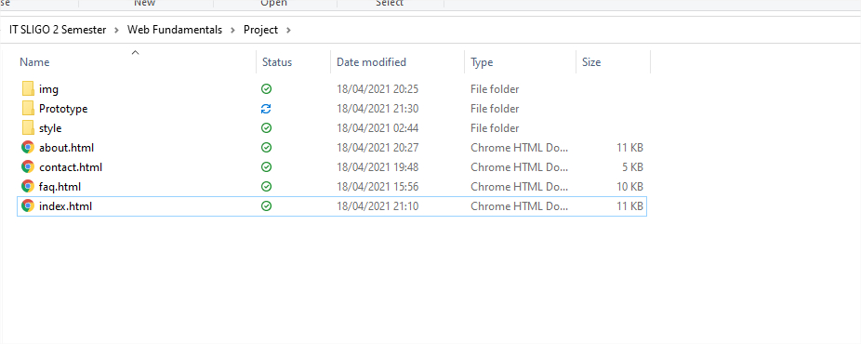

**INDEX**

BODY

The body is divided into the following sections header, nav, main section

80% of header, nav, footer and 75% my main, sections, lists.

Head contem keywords: “Dining, restaurant, book restaurants, download dining app, special offers,wonderful dishes".

Todas as palavras utilizadas contem na pagina index.

Logo displays top left

Background Image

Nav is inside the header with hover mouse effect

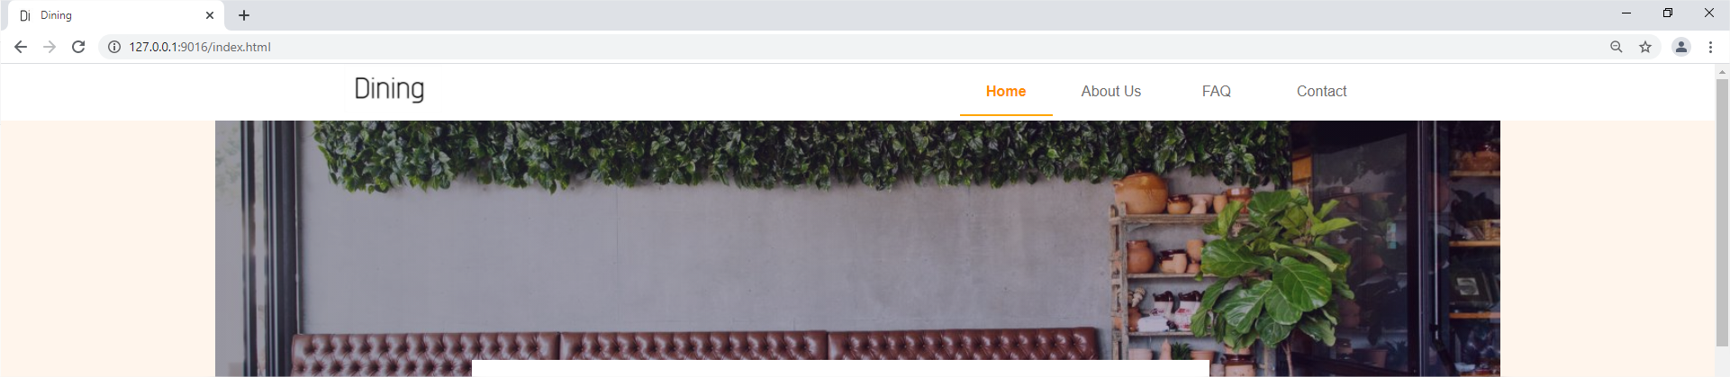

MAIN CONTENT

The main content will display imagens organizadas na primeira tela, bloco com imagens de pratos tipocos de restaurante gourmert , . 75% of the browser.

Background image is inside the main. this decision was made, because it was visually cleaner with the background image following the same size as the rest of the site.

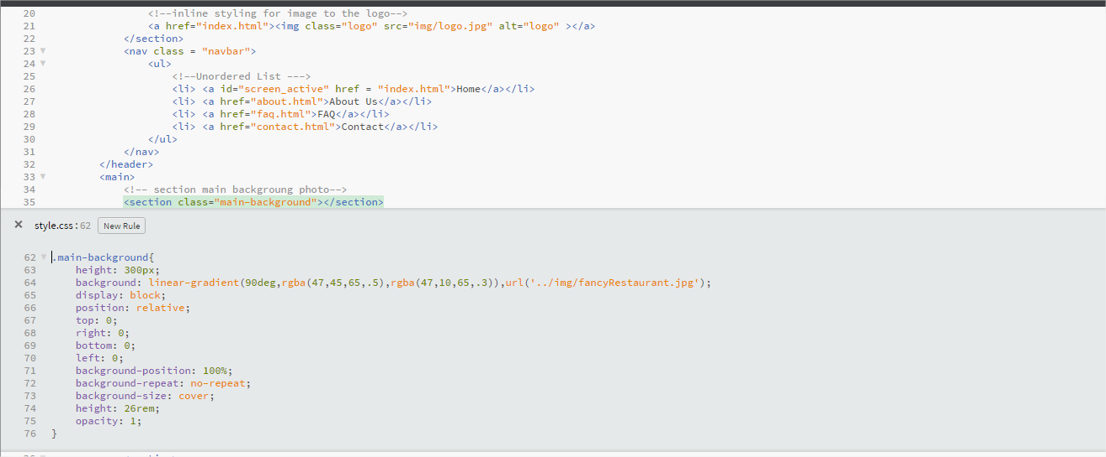

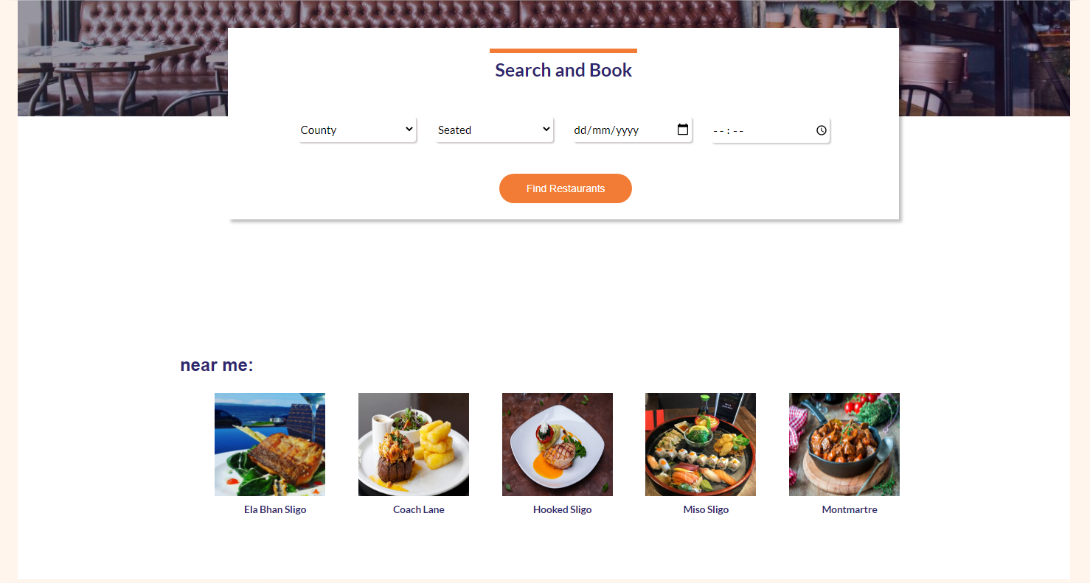it was necessary to create a container to better organize the user's search form.

after a further division was made, it was possible to organize the elements.

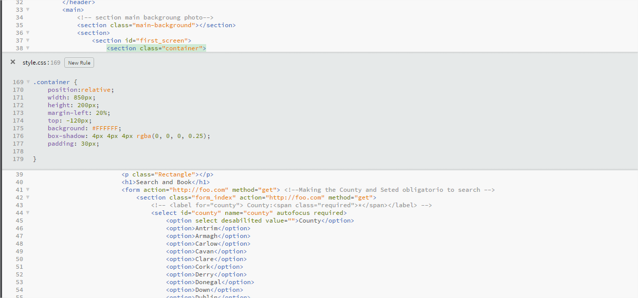

Class = rectangle is just a detail, wee orange thing in the container, just aesthetics in the form to be close to the initial prototype.

relative position to keep the container on top of the background image.